 | Student Name _______________________  Eastern Goldfields College  Mathematics Essential Unit 4 2018  Test 5
Working Time: 60 minutes | Total Marks: 49 marks

Calculator Free (No notes or calculator allowed) (14 Marks)

Question 1 (1 mark)

We express both ______________ and _____________ in degrees because they are measured as angles from the centre of the Earth to a point on the surface.

Question 2 (1 mark)

Earth has 24 different time zones each spanning how many degrees of Longitude?

Question 3 (1 mark)

What is the Latitude of the Equator?

Question 4 (2 marks)

Which method will result in a larger total over 3 years and why?
- $5000 at 2% pa compounded yearly, or
b) $5000 at 2% pa compounded half yearly

Question 5 (1 mark)

Daylight Savings is not practiced in South Australia. True or False?

Question 6 (1 mark)

In Summer Sydney is _______ hours ahead of Perth

Question 7 (1 mark)

Which location has a time zone that is ahead of Greenwich Mean Time?
15° E or 30° W

Question 8 (1 mark)

Express 12% p.a as a 6-monthly rate.

Question 9 (2 marks)

- A family took out a loan to pay for a $1000 dishwasher. Over the course of the loan, $200 of interest was accrued. How much did the family pay altogether?

- The family paid off the loan in 2 years. How much was their monthly repayment?

Question 10 (1 mark)

Write 8% as a decimal.

Question 11 (1 mark)

The graph below compares the growth of an investment calculated with compound and simple interest. Label the graph to distinguish which is which.

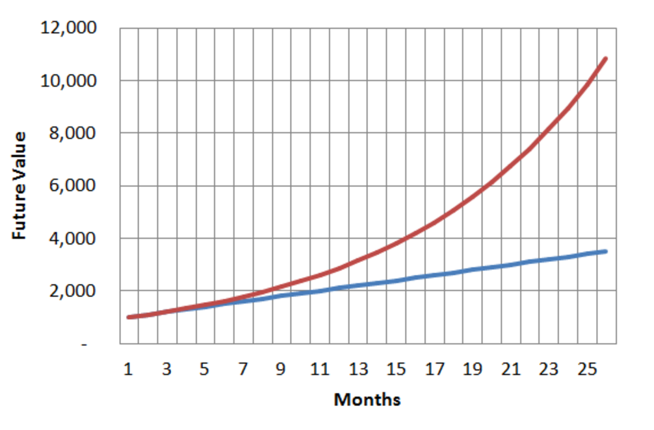

Question 12 (1 mark)

Give another real life situation, apart from compound interest, where amounts are compounded over time
Calculators and page of notes are allowed in this test. (35 Marks)
Answer all of the following questions. Show all working where appropriate to maximise marks.

Question 13 (5 marks: 1, 4)

In 2012 the Olympics were held in London, which is 0 GMT. In 2016 the Olympics were in Rio de Janeiro, which is -3 GMT. If Perth is +8 GMT;

- What is the time difference between London and Perth?

- In 2016, the Olympics Opening Ceremony was held on Friday at 7.30 pm in Rio de Janeiro. In the summer, Rio de Janeiro observes daylight savings, but Perth does not in summer. What day and time would you have expected to watch it live in Perth?

Question 14 (3 marks – 1, 2)

- Explain why Honolulu (21°N 157°W) and Barrow (71°N 157°W) have the same time.

- What is the distance in kilometres between Honolulu and Barrow?
[Use 6370 km as the radius of the Earth]

Question 15 (5 marks: 2, 3)

Perth is located at 31°S 116°E (UTC +8) and Sri Lanka (UTC +5.5) is located at 9°N 81°E.

- A 15° change in longitude corresponds to a 1-hour time difference. Use a calculation to show that there is a 2.5-hour time difference between Perth and Sri Lanka

- Sally took a non-stop flight to Sri Lanka that left Perth at 6.00 am on Saturday. The flight took 10 hours and 20 mins. What was the day and time of her arrival in Sri Lanka?

Question 16 (4 marks: 2, 2)

Shane buys a refrigerator on credit for $1200. He pays for the refrigerator in monthly instalments over the course of two years. Interest is added to the loan at a simple interest rate of 7% p.a.

- How much interest will be added to the loan over the two years?

- Calculate Shane’s monthly repayment

Question 17 (3 marks)

Complete the table below by converting the interest rates;

Yearly Interest Rate | Quarterly Interest Rate | Monthly Interest Rate
12% pa | 3% per quarter | 1% per month
7% pa
 | 6% per quarter
 |  | 1.5% per month

Question 18 (7 marks: 5, 2)

Janette wins $10,000 in the lottery. As she is sensible, she decides to invest the money. She has two options:

Bank A: Offers an interest rate of 10.5% p.a. compounded yearly over 3 years

Bank B: Offers an interest rate of 9.95% p.a. compounded half-yearly over 3 years

- Complete the two tables below to compare the two investment options:

Bank A

Period | Opening Balance | Interest | Closing Balance

Bank B

Period | Opening Balance | Interest | Closing Balance

- Which investment option would you recommend? Explain your answer.

Question 19 (4 marks: 2, 2)

Jethro borrows $9500 to buy a car. He makes monthly repayments of $330 (except the final repayment) over a 3 year period to pay off the loan. He is charged 15% pa. compound interest compounded monthly. The table below shows part of the progression of this loan.

Month | Amount Owing | Interest | Repayment | Balance
1 | $9500.00 | $118.75 | $330.00 | $9288.75
2 | $9288.75 | $116.11 | $330.00 | $9074.86
3 | $9074.86 | $113.44 | $330.00 | $8858.30
4 | $8858.30 | A | $330.00 | B
…. | …. | …. | …. | ….
34 | $936.23 | $11.70 | $330.00 | $617.93
35 | $617.93 | $7.72 | $330.00 | $295.65
36 | $295.65 | C | D | $0.00

- Determine the values of A, B, C and D from the table above.

A = ________ B = ________ C = ________ D = ________

- Determine the total amount of interest paid by Jethro over the period of the entire loan

Question 20 (4 marks)

For New Year’s Eve, this year, you decide to celebrate in Vancouver (Canada). Because flights are cheaper if they leave from Auckland (New Zealand), your flight will take 13 hours and 10 mins.

Auckland = UTC+12
Vancouver = UTC -7

Determine what time you would need to leave Auckland by to arrive in Vancouver by 8pm on the 31st December 2017.

END OF TEST

